TC-DVA-001
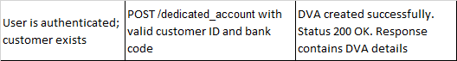
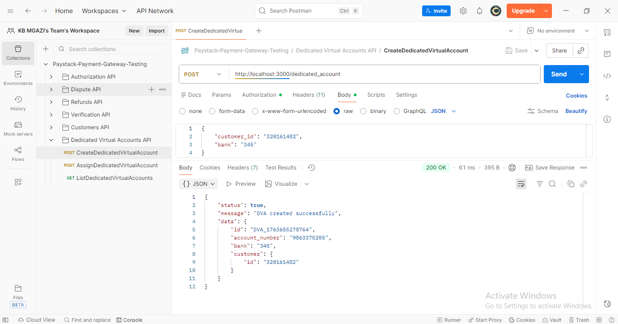
Request:
{
"customer_id": "320161482",
"bank": "345"
}

Response:
{
"status": true,
"message": "DVA created successfully",
"data": {
"id": "DVA_1763655278764",
"account_number": "9863375205",
"bank": "345",
"customer": {
"id": "320161482"
}
}
}

